- How do you use the "cp" command to copy a file named "file.txt" from the current directory to a directory named "backup"?
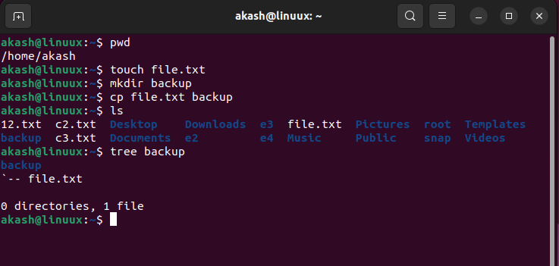

2 What is the difference between the "rm" and "rm -r" commands in Linux?
—> rm -r will recursively delete the directory and all its content
Rm will remove entries for particular file, group from directory.

3 How do you use the "mv" command to rename a file named "oldname.txt" to "newname.txt"?

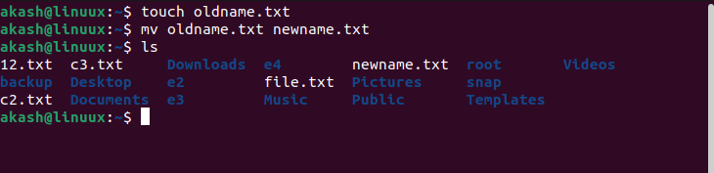

4 What does the "pwd" command do in Linux?
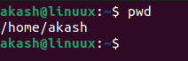
→ it will print the current working directory this will give you full path of current working directory

5 How do you create a new empty file named "newfile.txt" in the current directory using the command line?
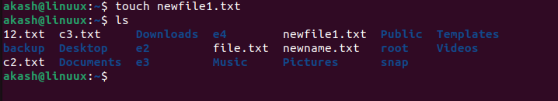

6 How do you rename a file named "oldname.txt" to "newname.txt" using the command line?
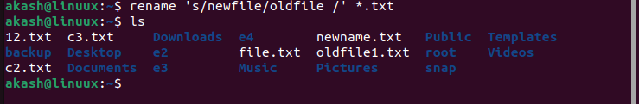

7How do you remove a file named "file.txt" from the current directory using the command line?
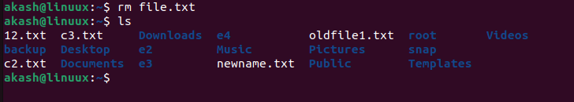

8 Display the man-page​ for ls​, but redirect the output into temp.txt​, then use the cat,​ less​, and more​ commands to display the new file.
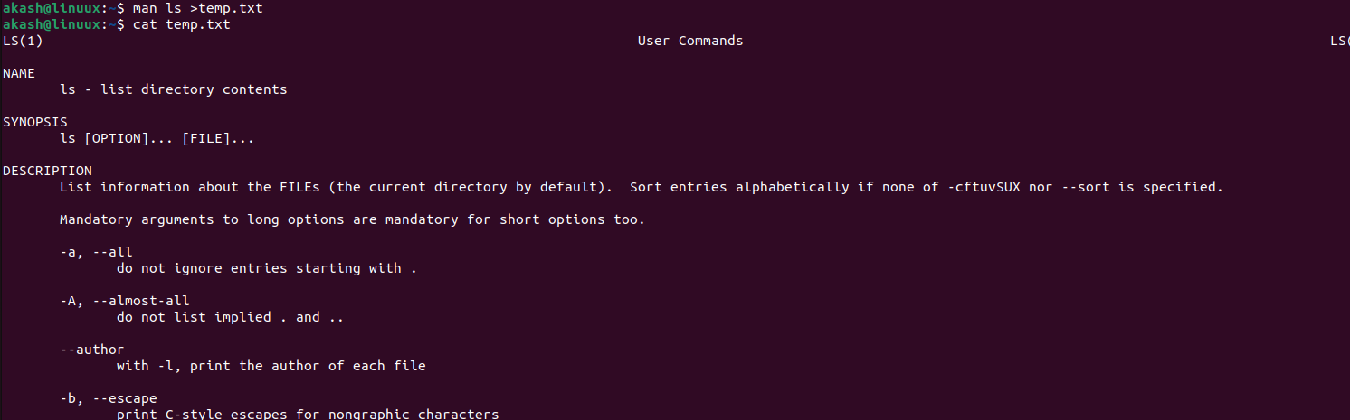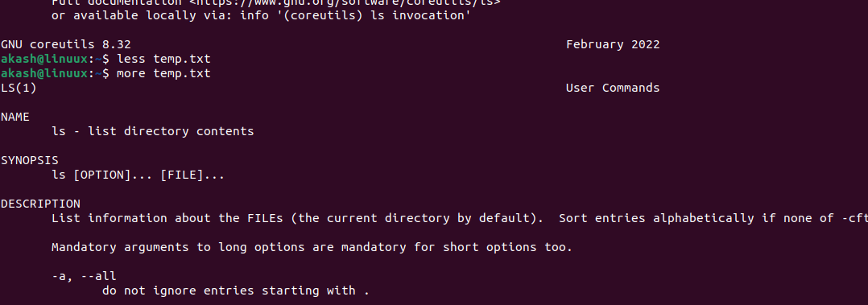

9 Display the initial 10 lines and final 5 lines of temp.txt​ with the obvious Linux commands
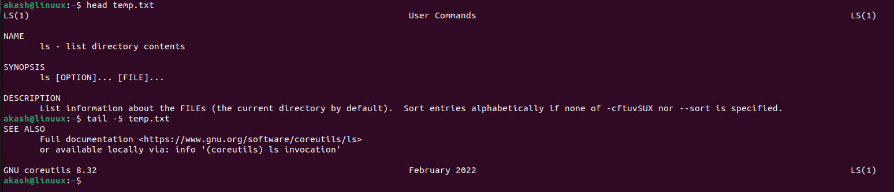

10 Copy temp.txt​ to another directory and rename it there.
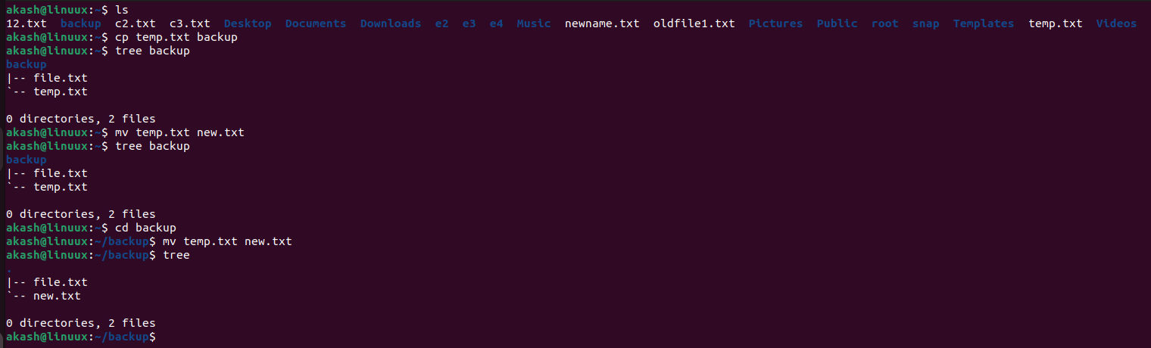

11 Display the number of lines, words and characters in file using Linux command

12 Use history command to display the last 10 commands used.
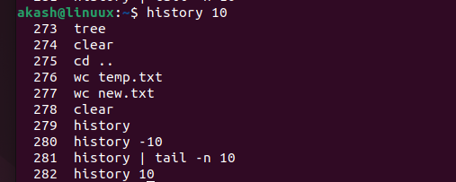

13Create a tar archive file of any directory present in your home directory

14 Create a zip file of another directory. (Hint​: use zip ​command) - list the contents of the zip file without extracting.
15 Give read, write & execute permissions to your file. (Hint​: use chmod command)
16 Change ownership of that file.(Hint​: use chown​ command)
21 Create one directory named linux. cd to that directory and create one file named testperms.txt. ​Check permissions of that file. Check value of umask​. Change the value of umask and create one new file newtestperms.txt ​and check its permissions. Note down the difference.(Hint: use umask, ls command )
22 Create a file and name it as file1.txt and create a hardlink to this file. (Hint use ln​ command).
23 Create a file and name it as file2.txt and create a softlink to this file. (Hint use ln​ command).

Hard Link | Soft link
Hard lng with being a link. | Soft link is a link which indicates path to  its parent file.
Since it is a file by itself, if parent file is  deleted, child file remains as it was  previously. | Since its a path, if parent file is deleted,  child doesn't point tp proper path and  becomes a zombie file.
Can be used for creating backup files. | Can be used as a shortcut.
Syntax is: In parentfile.ext childfile.ext | Syntax is: In -s parentfile.ext Q  childfile.ext (here, -s indicates soft link)
24 Use ssh​ to connect to your friends shell by specifying port number​ in the ssh command. use exit ​command to come out of your friends shell.
(Hint: use ssh​ command)
25 Use scp​ using your friend's credentials to copy file​ into a directory owned by your friend, ​inside his home directory, specify port number in scp​ command.

26 Use scp​ using your friend's credentials to copy directory​ into a directory owned by you​, inside your home directory, specify port number in scp command

27 Use scp​ using your friend's credentials to copy directory​ into a directory owned by you​, inside your home directory, specify port number in scp command

28 Connect to any publicly available ftp​ server from terminal and try to download, upload and delete files. If you get error in any process (connect, upload, download or delete), justify the reasons behind them.(Hint: use ftp​ command) Example:
Try to access ftp.netbsd.org
username : anonymous
password : anonymous

27 How do you remove a directory named "mydir" and all of its contents using the command line?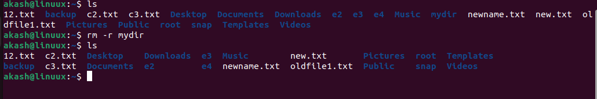
29 How do you create a new file named "myfile.txt" in the directory "/home/user/documents" using the command line?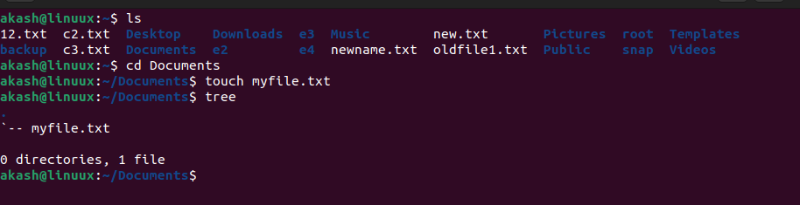
30 How do you use the "grep" command to search for a specific word or phrase in multiple files at once?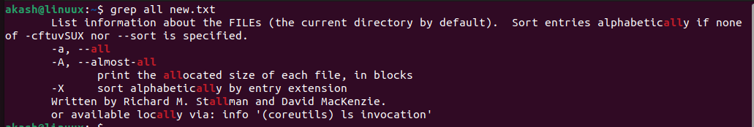
31 How do you create a new directory named "mydir" and set its permissions to read, write, and execute for the owner and read and execute for everyone else?
32 How do you use the "tar" command to create a compressed archive of all files in the current directory and its subdirectories?
33 How do you use the "chmod" command to give read and write permissions to the owner and group for a file named "file.txt"?
34 How do you find the size of a file named "file.txt" in bytes, kilobytes, and megabytes using the command line?
35 How do you use the "awk" command to extract a specific column from a comma-separated value (CSV) file and sort it in reverse order?
36 How do you use the "sed" command to replace all occurrences of a word or phrase in a file with a different word or phrase?
37 How do you use the "find" command to search for all files in a directory and its subdirectories that were modified within the last 24 hours?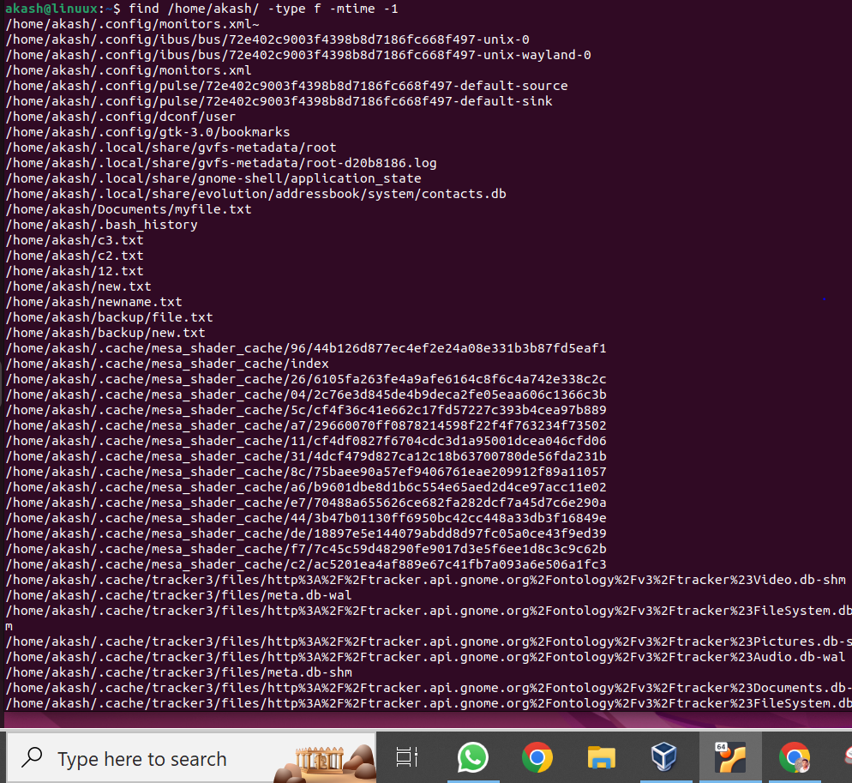
38 How do you use the "diff" command to compare two files and show only the lines that are different between them?
39 How do you use the "rsync" command to synchronize the contents of two directories, including all subdirectories and files, while preserving file permissions and ownerships?
40 How do you use the "cut" command to extract a specific range of characters or bytes from a file?
41 How do you use the "tar" command to extract a specific file or directory from a compressed archive without extracting the entire archive?
42 How do you use the "awk" command to count the number of occurrences of a specific word or phrase in a file?

